Documentation Ecosystem Modernization

1. Executive Summary
This document is to modernize the documentation ecosystem to improve the customer experience, accelerate product releases, and enable AI-powered content operations. This document summarizes the gaps observed on the current documentation portal (docs.qualys.com) and lays out a phased approach to close them, starting with foundational UX and information architecture work and building toward AI-powered capabilities for both customers and the writing team.

2. Current State: Observed Pain Points
A review of the existing portal surfaced the following gaps:

2.1 Navigation and Discoverability
- Search does not offer autosuggestions based on partial input.
- Content is organized into categories such as Risk Management and IT Security, but there is no way to filter search results by category on the home page. You have to first search, and then you will have to find the relevant filters.
- Deep product or release pages (for example, the Enterprise TruRisk™ Platform Release 10.39.1 API page) provide no way back to the homepage.
- Some page content remains unreachable, even after scrolling to the end of the page.
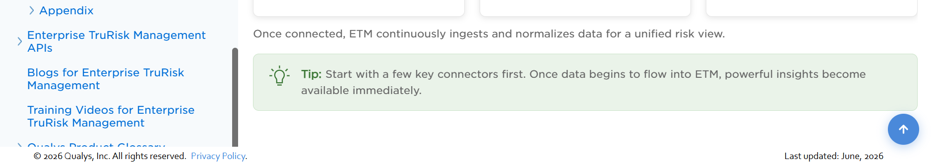

2.2 Content Presentation and Consistency
- Release Notes and the Newsletter are treated as ordinary sections, despite the fact that they could be among the most frequently visited content on the site. They should be highlight of the page, and the link leading to it should not be an ordinary page.
- Heading hierarchy is inconsistent. For example, “Cloud Apps” renders as a disproportionately large header compared to everything else on the page.
- Table of Contents styling differs from product to product.
- Font colors are inconsistent across product documentation.

2.3 Accessibility and Self-Service
- There is no option for users to download documentation as a PDF for offline reference (this may carry its own security considerations, worth evaluating separately).
- There is no mechanism for readers to leave feedback on content.
- There are products where you have a direct link to documents like Getting Started, but not the same for all products.
- Like this, many content presentation related issues are not consistent.

2.4 Product Help portal and Context-Sensitive help
- The screenshot provided in the assignment does not show a Help link.
- If this is confirmed, I'd like to propose adding a Help link within the product itself.
- Currently, users must navigate to a separate portal to access documentation and content.
- As a result, finding step-by-step guidance for a specific page requires extensive manual searching.
- Along with the Help link, I would also like to introduce context-sensitive help. Customers will press F1 help on any page, and the relevant content is available to the users.

3. Proposed Approach
The proposal is organized into four phases: innovation team formation, portal and UX redesign, AI-powered customer experience, and AI-powered enablement for the writing team. Phase 1 can start right away, since it works with content that already exists. Phases 2 and 3 build on that foundation.

Phase 0 – Documentation Initiative Team Proposal
I am not sure about the current number of writers or how the teams are structured. However, I propose creating a Documentation Initiative Team consisting primarily of Senior Writers who will be responsible for driving continuous improvements across the documentation organization.

Proposed Approach
- Form the Documentation Initiative Team.
  - Invite interested writers to participate in the initiative.
  - Establish a core team of Senior Writers to lead planning, execution, and governance.
- Appoint Group Representatives (Spokes)
  - Assign a representative ("Spoke") for each documentation group.
  - Each Spoke will:
    - Represent their respective team.
    - Gather ideas, feedback, and improvement opportunities.
    - Communicate team-specific challenges and requirements to the core team.
- Identify and Prioritize Initiatives
  - The core team will review the collected ideas and prioritize initiatives based on business value, impact, and feasibility.
  - Initial efforts should focus on implementing a few high-impact, foundational improvements before expanding to larger initiatives.
- Track Work Through Jira
  - Create a dedicated Jira board to manage all documentation initiatives.
  - Each initiative will have its own Jira ticket with clearly defined tasks, owners, timelines, and progress tracking.
- Assign Ownership
  - Every task will be assigned to an individual writer who will be responsible for:
    - Coordinating with the appropriate stakeholders.
    - Driving the task to completion.
    - Providing regular progress updates.
    - Core team members, along with documentation leads and managers, will ensure the required collaboration from product teams and other stakeholders whenever needed.
- Conduct Regular Status Reviews
  - Hold weekly meetings to:
    - Review progress.
    - Resolve blockers.
    - Reprioritize work when necessary.
    - Ensure initiatives remain on schedule.
- Close and Validate Completed Work
  - Each task should be formally closed after implementation and validation.
  - Lessons learned and outcomes should be documented for future reference.
- Roll Out New Enhancements
  - Once an initiative is completed:
    - Announce the enhancement to all documentation teams.
    - Conduct knowledge-sharing or training sessions to ensure successful adoption.
    - Publish any required process documentation or best practices.
- Share Quarterly Progress
  - At the end of every quarter, present a progress report to senior management highlighting:
    - Completed initiatives.
    - Current work in progress.
    - Upcoming roadmap.
    - Overall impact on the documentation organization.

Success Metrics
The objective of this initiative is not only to introduce new enhancements but also to demonstrate measurable business value. Every initiative should, where possible, capture metrics such as:
- Cost savings achieved through automation or process improvements.
- Improvements in documentation quality and consistency.
- Productivity gains for writers.
- Reduction in documentation effort or turnaround time.
- Business value delivered to customers and internal stakeholders.
- Real-world use cases demonstrating the impact of the implemented enhancements.
By following this structured approach, the Documentation Initiative Team can continuously improve documentation processes, increase collaboration across teams, and provide measurable value to both the organization and its customers.

Phase 1 – Portal and UX Redesign
- Categorized homepage with hover previews: Redesign the homepage so it shows only top-level categories, with a hover interaction that reveals the respective products, rather than listing every product upfront.
- Writer-owned product portals: Give each writer ownership of their product section (some writers may own more than one product). Each writer can propose the information architecture for their product and get stakeholder sign-off, while a central team defines the shared elements – search, tabs, navigation – that every product page inherits. If we have some amazing ideas from the writers, then the leaders will approach the stakeholders of other products and showcase the same for their product. Once we have a go-ahead, we will keep on adding the features.
- Tabbed document layout: Consolidate related documents onto a single page using a tabbed layout, instead of requiring users to move between separate pages. Example shown below:
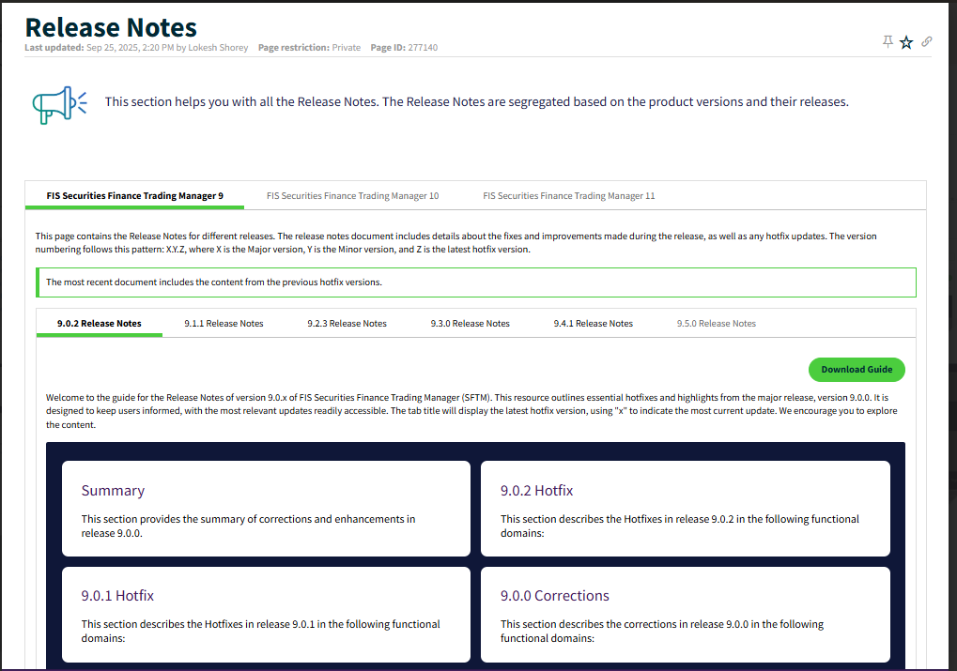
- Scoped search with an expandable option: Index each product's content separately, and default search results to the current product. A site search engine, configured with a per-product index, handles this well. Add a search bar scoped to the current product page by default, with a dropdown to expand the search across the entire portal.
- Release-version tabs: Replace the practice of appending new documents to a flat, ever-growing table of contents with version-based tabs, so users can jump straight to the release they need.
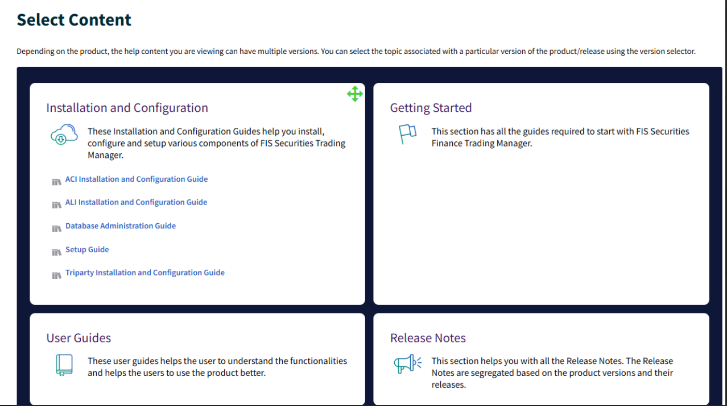
- “Recently Updated” section: Add a “Recently Updated” section under each product so the latest changes are easy to find.


Phase 2 – AI-Powered Enablement for the Writing Team
To have sufficient bandwidth for our writers, we will have to first ease out their work, and to do so, let us first implement AI support for their work.
- Style and content governance: Integrate a writing-assistance tool, such as Grammarly Business, configured against the Qualys writing style, so content is checked automatically for tone and consistency before it is published. This will help us get more bandwidth from our writers.
- SEO and GEO-compliant content: Review and edit our current content guide by guide to make the content SEO and GEO complaint of not already. Add tags at the topic level so that the content is extracted for an AI-based chatbot.
- Jira, Confluence, and GIT integration: Integrate Jira, Confluence, and GIT with an AI assistant (such as Claude, ChatGPT, or Copilot), authenticated through SSO, so writers can query these systems directly – for example, to pull every ticket assigned to a given owner. I have already tried this using Power BI, and it is a 100% workable idea.
- Ticket retrieval and Fix Version filtering: Allow filtering of retrieved tickets by Fix Version, the field Scrum Masters already use to track release scope.
- Auto-drafted release highlights: Use the retrieved ticket data to auto-draft the first version of release highlights, which writers then review and refine.
- Direct publishing, as a second stage: In a second stage, connect this workflow to the documentation publishing tool so approved drafts can be pushed directly to publication.

Phase 3 – AI-Powered Customer Experience
- Content already available: The good part is that we already have the content available that can be used for AI implementation.
- Internal vs external content segregation: If we have draft versions of documents as well on the portal that are only visible to internal people, then we will have to use that separation method in our AI approach so that internal content is not visible to the external audience. This can be done by adding tags to the topics.
- AI chatbot for end-users: Introduce an AI chatbot, integrated with an AI chat engine, directly into the documentation portal. The login method will be the same that we are currently using (if any). SSO authentication is possible with the AI-based chatbots as well.
- Role-based filtering: Make sure chatbot and search results are role-based, so users see results relevant to their entitlements.
- Additional Functional Content: One approach we might have to take is to add the functional documents as well, so that the results are better refined.

Ongoing Phase – Individual Product-level Implementations
- Process and content enhancements: As leaders talk to individual product stakeholders to convince them to get a Help link and F1 context-sensitive help. Once approved, give a roadmap and then implement it as per the roadmap.
- Content improvement: While reviewing the release notes documents, I noticed several inconsistencies in formatting and style. For example, the use of the comma (the comma before 'and' in a list) was inconsistent — it appeared in one document but was missing in another document for the same product.

4. Expected Benefits
- Increased Writer’s bandwidth: More bandwidth for our writer to implement new enhancements with AI-powered tooling for writers that improves productivity and consistency.
- Improved Doc Portal UI: Better presentation and easier access to documentation for end users.
- Reduced User’s Efforts: AI-powered search that reduces the effort needed to find the right content.
- Ready with Future Implementations: A foundation that is usable now and structured to scale toward deeper AI-powered content operations later.

5. Future vision
Once we have some visible results, let us start getting some budget for training our resources on new technologies to reduce dependencies on other teams. Considering the future, it will be better to adopt more technologies or functional domains.

